**Registered No: 20218411**

**Name: Anuj Solanki**

**(Practical 7):- Introduction to Menus & Toolbars and their properties**

**Aim:**

**a. Menu Strip**

**b. Status Strip**

**c. Tool Strip**

1. **Menu Strip**

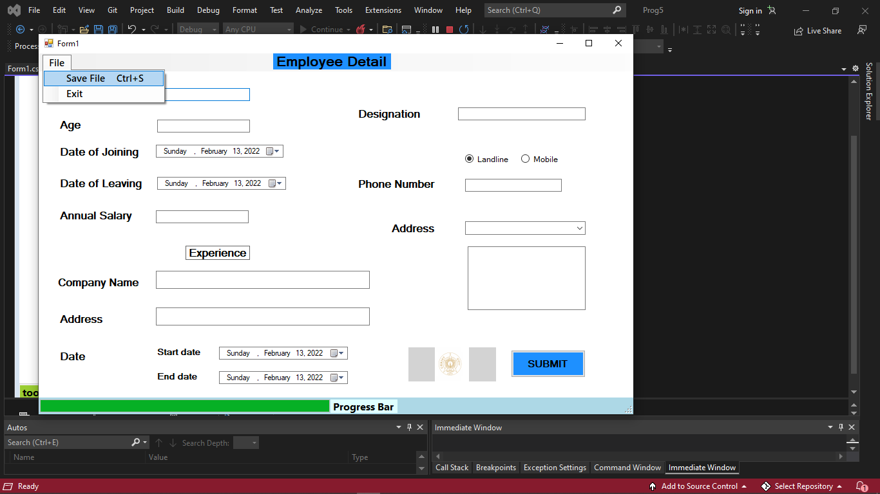

**2) Status Strip**

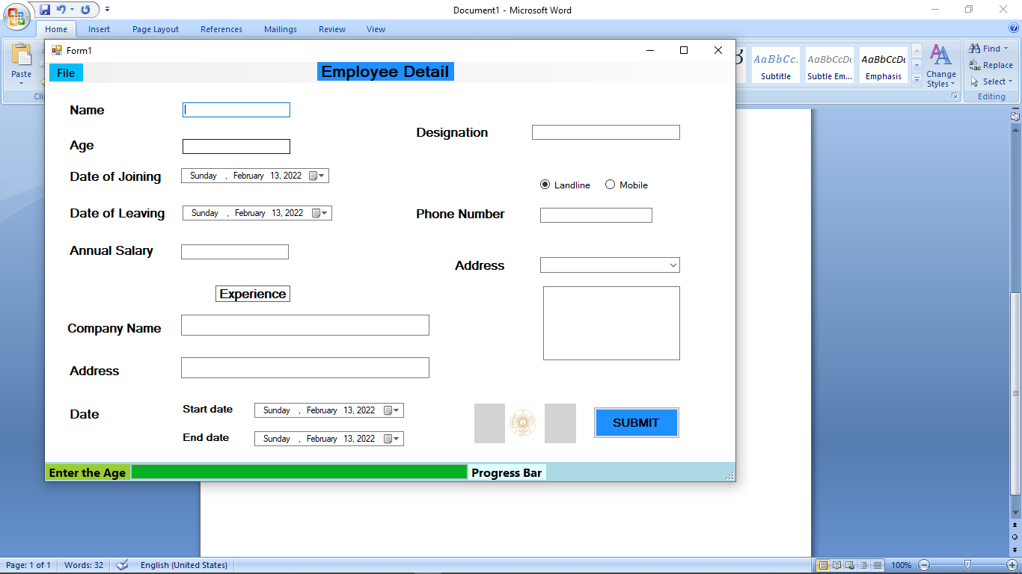

1. **Tool Strip**

